Assignment -3 Bucket And Watson assistant

|  |  |
| --- | --- |
| **Assignment Date** | **7 October 2022** |
| **Student Name** | **Kiran S** |
| **Student Roll Number** | **727720EUCS503** |
| **Maximum Marks** | **2 Marks** |

1. **CREATE BUCKET IN IBM CLOUD STORAGE:**

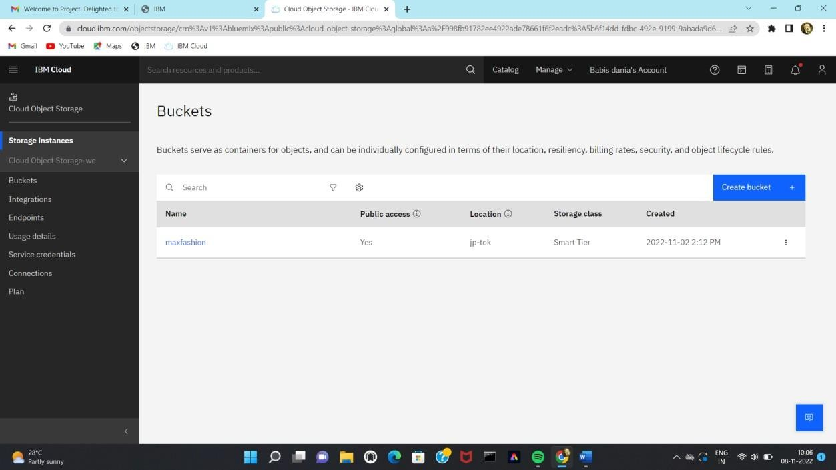

1. **UPLOAD 5 IMAGES AND CSS TO THE CLOUS STOREGE**

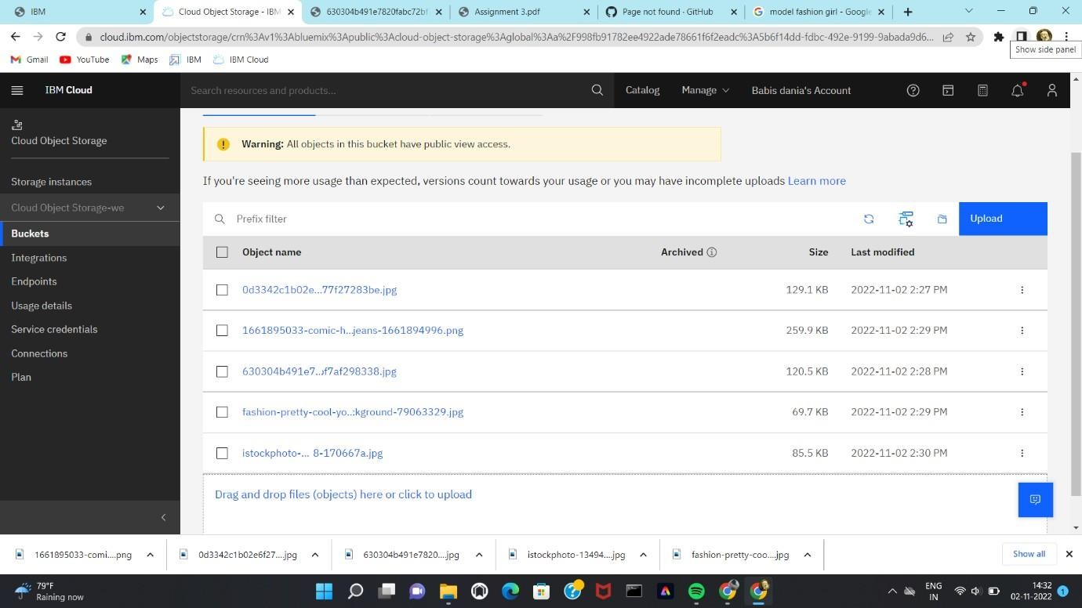

1. **DISPLAYING IMAGES AND CSS CODE FROM THE CLOUD:**

1. **CREATE A WATSON ASSISTANT CHATBOT WITH 10 STEPS AND 3 CONDITION:**

